**Admin Bar**

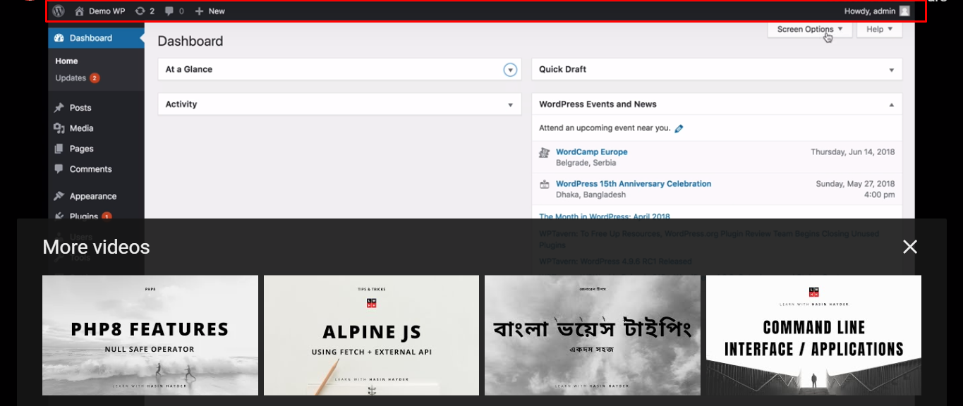

Post sticky kra jay, krle oi post sobar upore thakbe.

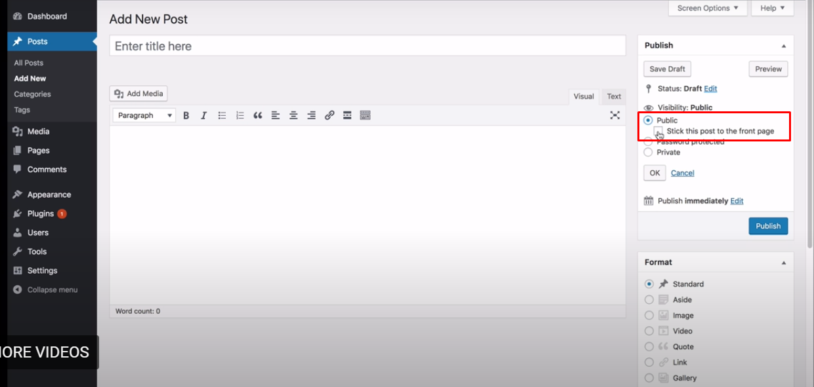

**Post Format**

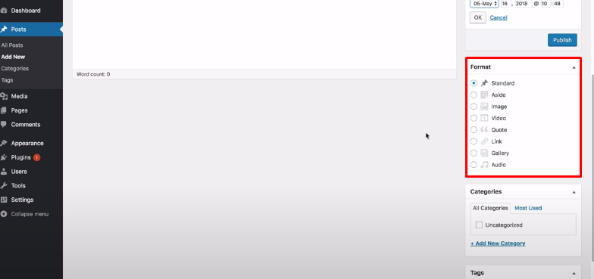

In tags & categories, plugin developer can add extra functionalities.

Post section contains excerpt (summary)